HELP WANTED
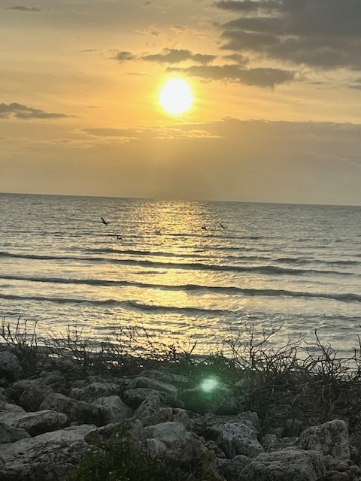
BAHIA HONDA STATE PARK CONCESSION

Bahia Honda State Park Concession (Coral Reef Park Co., Inc.) - Big Pine Key FL:

Looking to fill the following position with personable, outgoing individuals who have a background in customer service. Part-time positions are available with the potential to become full-time. Health benefits are offered to employees and time and a half is offered after 40 hours per week. Must be able to work weekends and holidays. Positions needed are as follows:

Snack Bar Attendant-Greets customers and takes food orders. Operates the cash register and receives
payment from customers. Cleans and stocks work area. Assists with a variety of kitchen related
functions as needed. Ensures proper food handling procedures are followed including wrapping,
labeling, dating, stocking, storing, rotating and checking temperature of products. Cleans and sanitizes
work stations and equipment.

Snorkel Boat Mate (Competitive pay plus tips) – Full Time/Part Time position. Divemaster or Scuba Instructor Certification required. PADI First Aid and CPR, Current within 12 months. PADI/DAN Membership Dues current.

Snorkel Boat Captain (Competitive pay plus tips) - Full Time/Part Time position. Divemaster
Certification Recommended. 50 ton USCG License required. PADI/DAN Membership Dues Paid as
Well as Individual Professional Liability.

Please contact Tonya 305-872-9939.

We are a drug free (NO TOLERANCE) and an Equal Employment Opportunity Company.

